INFILLING THE GAP AT CORWEN
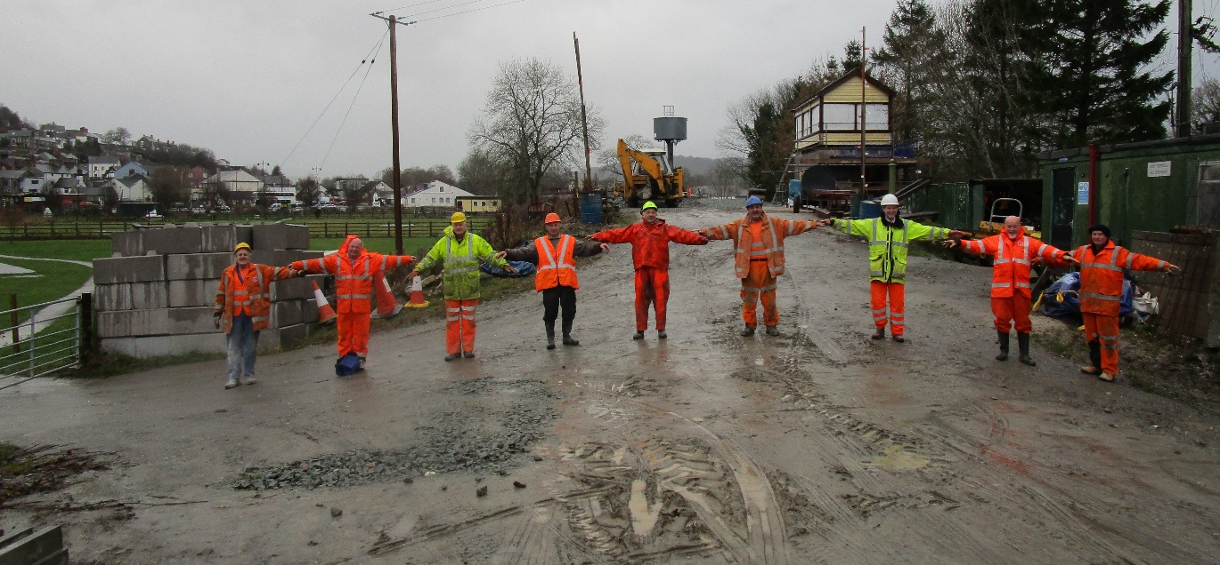
As we conclude the building of the island platform and loop line, the Corwen Central Project’s focus turns to the infamous Gap in the embankment, long seen as the big obstruction on the trackbed.
Originally bulldozed through to provide alternative access to the Corwen Sewage Farm, the gap was further eroded in 2013 by contractors for the Corwen Flood Relief Scheme and has since provided the essential access for the road delivery of materials for the project. Recently it offered the only route for the Water Tower and Signal box cabin to be brought in for installation.
With all that behind us, early in 2019 we will be looking for a contractor to deliver and compact the spoil to reinstate the embankment for the connection of the two railheads and the laying of a parallel extended siding. The estimated volume is 9,000 cubic metres, requiring 11,250 tonnes of spoil at a cost of £10,000, which we need to raise to pay for this work that is beyond the capability of the volunteer Project team.
Help with financing this final challenge in completing the Corwen terminus is again sought from Supporters following the success of the Appeal which has financed the platform infill. The difference is the time is shorter and the reward for supporters will be the sight of the train arriving at the new station across the final frontier, something we are all waiting for!
With your help we will reinstate the Gap and donations to this Appeal will be welcomed by our Treasurer, Mr Paul Bailey, ‘Dolwen’, Bryn Eglwys, Corwen LL21 9LY
_______________________________________________________________________________________
YES, I want to help Infill the Gap with the sum of £25/£50/£100, or my own choice of £….... and enclose my cheque payable to CCRD (Corwen Central Railway Development) in support of the Appeal. Donations £100 and over will receive four tickets for free travel on normal timetable service trains in 2019, not available on special events.
Name……………………………………………………………………………………………………………………………..……………………..
Address…………………………………………………………………………………………………………………Post Code…………….….
Email (for acknowledgement only)………………………………………………………………..……………………………………………
Cash is equally acceptable if handed in to the Project’s Site Office at Corwen during working hours
Llangollen Railway Trust Ltd, Registered Charity No.1046614 LRT1/2019

